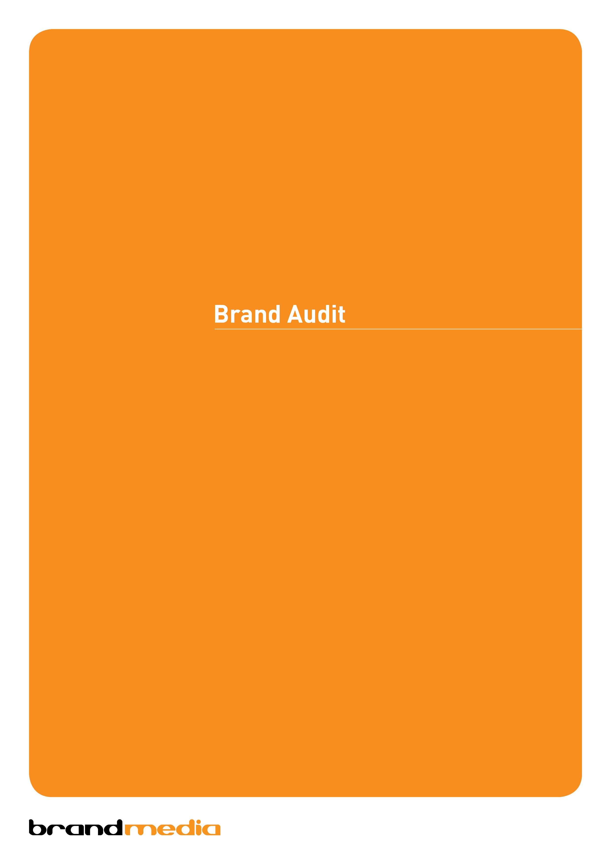
Company Name: _____________________________________________________________________ DATE: ___ / ___ / ____

A Brand Audit will provide us with an understanding of your business needs, goals and values. By gaining a thorough understanding of your business, we will be able to produce design that reflects what you want for your business.

1. Defining your business
In a few short sentences, what does your business offer to your customers?

2. Define your product/service appeal
By defining your product/service appeal we will be able to create a design that highlights important factors and makes the design appealing to your target market.

3. Identify your target markets
Identifying your potential clients is a key factor in your branding strategy. Your “look” will position your brand correctly and add an emotive factor that sets you apart from your competitors. Your brand image can be; bright, dark, serious, fun, professional, established, quiet, loud and so on. It should reflect who you are and have high appeal to your target audience.

4. Discuss forms of communicating your identity to your potential market
There are many promotional options to get your company known. For instance you might like to have a dedicated Company Face Book account to keep customer up to date with what’s happening in your industry or resent case studies. These marketing options allow you to use your identity to show customers that you offer something that they need.

5. Create a Brand that works for you
With so many options of gaining attention for your product/service, you need a Brand that stands out
from the crowd. After all, this is what your customers will think of when they hear/see your name.

6. Manage your Brand to ensure that you get the best results
By working closely with you a Brand Agency will be able to develop strategies which will ensure that your message is clear, consistent and most of all catchy both in the short term and long term.
Whether you are a new or existing business, hiring a Brand Agency will provide you the assistance you need to create your unique business personality with a whole new design or a refreshed version of your existing Brand.

1. Defining your business?

2. Define your product/service appeal

• What advantages do you have? e.g. competitive advantages, price, value, quality, USP’s, Innovative aspects,
marketing - reach, location, distribution, awareness..

Strengths

• What do you do well? e.g. why customers are loyal to your products or services

• What relevant resources do you have access to? e.g. assets, people, processes, systems, IT, communications...

• What do your customers consider as your strengths?

3. Identify your target markets
Identifying your potential clients is a key factor in your branding strategy.

• From the list below, number the boxes that are most apply to your Brand, with a rating 1 to 5 with 5 being the lowest.

Honest | Proud | Approachable
Friendly | Down-to-earth | Exceptional
Ethical | Entrepreneurial | Innovative
Cutting Edge | Professional | Supportive
Influential | Leaders in your field | Quality
Price Driven | Team Work | Respectful
Environmentally Conscience | Fair | Practical

• What percentage of the market share do you estimate to have? ________%

• What are your short term goals?

• What are your long term goals?

Weaknesses:
Again, consider this from an internal and external basis: Do other people seem to perceive weaknesses that you do not see? Are your competitors doing any better than you? It is best to be realistic now, and face any unpleasant truths as soon as possible .

• What could you improve on? e.g. reputation, presence and reach, time scales, deadlines, processes and systemslack of competitive strength, planning...

• What areas of your business preform poorly? e.g. own known vulnerabilities, gaps in capabilities...

• What should you avoid? e.g. effects on core activities, distractions...

Opportunities:

A useful approach to looking at opportunities is to look at your strengths and ask yourself whether these open up any opportunities. Alternatively, look at your weaknesses and ask yourself whether you could open up opportunities by eliminating them.

Useful opportunities can come from such things as:

• Market developments? | • New USP’s?
• Competitors’ vulnerabilities? | • Tactics - surprise, major contracts, etc?
• Industry or lifestyle trends? | • Business and product development?
• Technology development and innovation? | • Information and research?
• Global influences? | • Partnerships, agencies, distribution?
• New markets, vertical, horizontal? | • Volumes, production, economies?
• Niche target markets? | • Seasonal, weather, fashion influences?
• Geographical, export, import?

Where do you see the greatest opportunities coming from? e.g. niche target markets

Which areas of your business do you see the largest growth coming from? e.g. commercial sector

What factors most influence transactions within your industry?

Threats:
For example:
• Political effects? | • Sustaining internal capabilities?
• Legislative effects? | • Insurmountable weaknesses?
• Environmental effects? | • Seasonality, weather effects?
• IT developments? | • Loss of key staff?
• Vital contracts and partners? | • Sustainable financial backing?
• Market demand? | • Economy - home, abroad?
• New technologies, services, ideas?

• What obstacles do you face?

• What is your competition doing that you are not?

• Are the required specifications for your job, products or services changing? Yes No
If yes what are they?...

• Is changing technology threatening your position? Yes No
If yes what are they?...

• Could any of your weaknesses seriously threaten your business?

4. Discuss forms of communicating your identity to your potential market
• List all your existing sales collateral and advertising activities by ticking the appropriate boxes?

Stationery | Company Profile | Product Flyer
Product Point of Sale | Direct Mailer | Newsletters
Catalogue | Magazine Advert | Press Advert
Packaging | Billboard | TV
Radio | Web Site | Signage
Stationery | Company Profile | E-Newsletters
Product Point of Sale | Direct Mailer | Social Media

5. Create a Brand that works for you
• Do you feel your current image best represents your brand values? Yes No

• What areas of your brand marketing do you feel require immediate attention?

6. Manage your Brand to ensure that you get the best results
In order for brandmedia to understand the level of your brand communications we need to find out the amount to which you allocate to your marketing spend. This can be an approximate figure, as we are aware this information is privileged, which is why we treat this with the utmost confidentiality.

$0 - 50,000 | $50,000 - $100,00 | $100,000 - $200,000 | $200,000

In terms of percentages how is your marketing spend allocated? e.g. 50% Print Media

• Do you currently have a Brand Strategy in place? Yes No
• What would be your greatest priority with taking your Brand forward?

